Traditional Computer Vision Approach using Filters

Understanding Traditional CV
Convolution operation and classical filters : The Heart of Computer Vision
- Filters or Kernel = simple matrices (3*3 or 5*5). Hand engineered matrices.
- There are many techniques involved in identifying the edges or corners etc. These features convolve with the image. This operation allows us to identify edges, features etc.
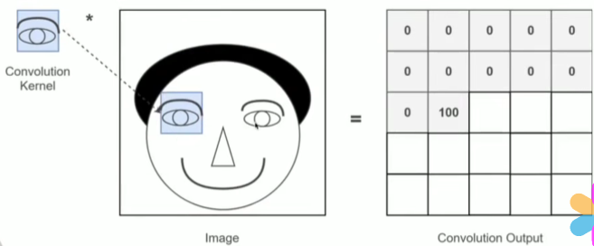
Eye is the kernel so whenever the kernel matches with the image the output shows 100(high intensity) otherwise it shows 0 (low intensity).

Why should we use filters if deep learning has taken over computer vision.
- Filters are vital for foundational understanding.
- Convolution filters are still imp.

Understanding filters from scratch
Image Filter and Convolution
- ImageFilter / Kernel will be a small matrix. Size = 3 * 3, 5*5 etc
- Image size is also small and images will be of low resolution
- Images generally are of low resolution they are not too perfect and even kernel is also of low resolution.
- While performing convolution center pixel of the kernel should align with the pixel of input and if any of the kernel is outside the image then it should have padding added. So the output has the same dimensions as the input.
- We do element wise dot product and sum the values.
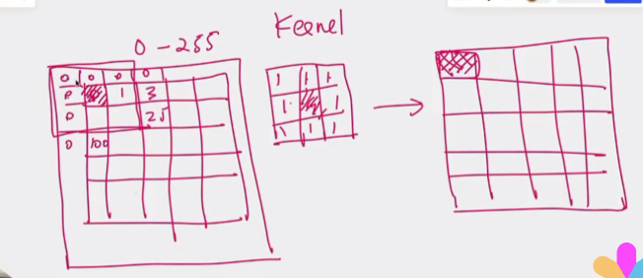
Stride = 1 -> we are moving the kernel one pixel at a time.
Bigger the stride the more the padding should be .
Bigger the size, add padding to retain the size.

Kernel captures the features from the input and transfers it to the output.
Convolution is a mathematical operation where a small matrix (kernel) slides over the input image, performing a dot product within the overlapping region to generate a new matrix representing transformed features.

Why are we using filters

Filters can perform useful operations present in image processing
- Feature extraction -> Detect edges, corners, or textures
- Noise Reduction -> Smoothing filters like Gaussian blur
- Enhancement -> Some filters sharpen or enhance edges to make further analysis.
- Pattern recognition -> Long before neural networks many CV tasks involved carefully chosen filters plus rule based heuristics.

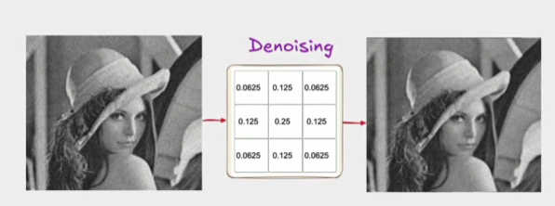

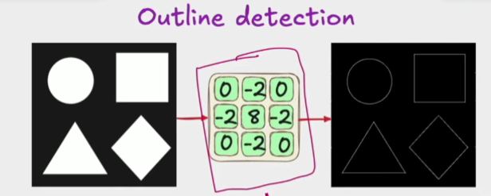

This is outline detection so the kernel can identify edges from any image .

Building Filters

How did we come up with those filters which work on any image

- Classic Filters -> Sobel, Prewitt, Laplacian etc.

Approximating derivatives in 2D
- Edge -> Edge is a place where the intensity of an image changes abruptly.
- We cannot represent the derivative as a continuous function so that is why we will use finite differences.

For an image whose pixel values can be described as I(x,y) you have partial derivatives change in x direction and similarly 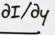 change in the ydirection.
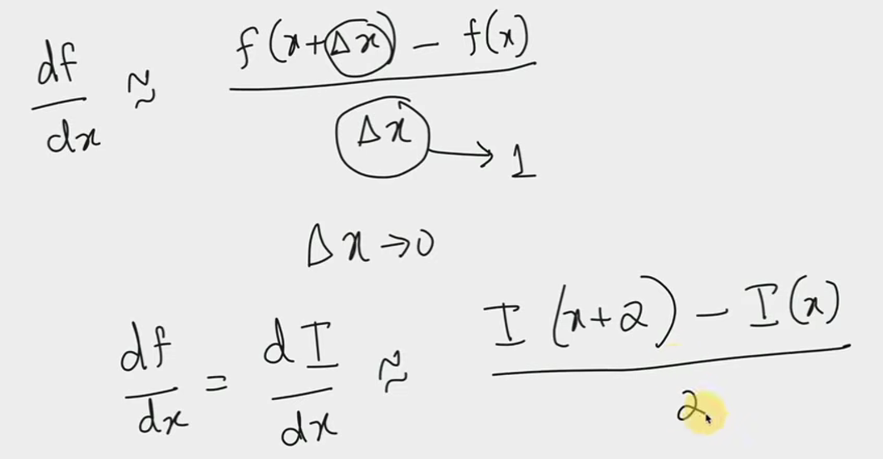 -> EULER’s

If function is a sequence of values then the difference between the neighbours
represent how fast the function is changing.

If you want to calculate the rate of change of intensity of I(x),

(I(x+1) - I(x-1)) / 2
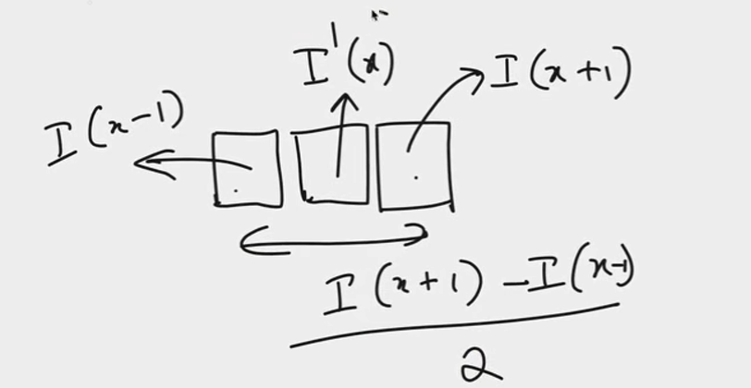 This can approximate the rate of change of intensity value

Filter = [-1 1]

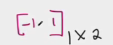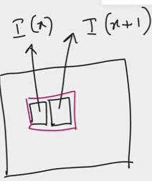 = I(x+1) * 1 + I(x) * -1 = I(x+1) - I(x) = dI/dx

Derivative (I(x)) = I

So a simple filter like [-1, 1] can give us the edges. Subtracting the 2 adjacent pixels and attributing that difference to a new filter can give us some approximation about edges.

Here in this type of filter we are taking the difference of the 2 adjacent filters but inreality images have noise so we cannot get appropriate results. Which is why we consider Sobel or Prewitt filters.

Sobel Filter

Sobel filter approximates 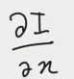.

This is the sober filter 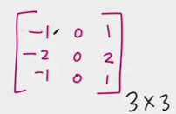. This is used to derive the derivative. But there is some smoothing that is happening here.

2 things = Smoothing + Differentiation
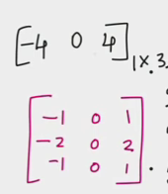 -1 -2 -1 = -4 = 4 [-1 0 1] = 4 * [ I(x+1) - I(x-1)] = dI / dx

Why is Sober filter smoother than [-1, 1]
So in Sober filter because we consider left, right , top pixels and bottom ones while calculating the single edge pixels, what happens is if there is a noisy pixel at one point which is the black pixel inside the white shaded area then

- if we consider the previous filter in that case we will not be able to find that there is an edge because the 2 adjacent pixels are black so the difference will give us 0.

- But with sober filter since we are considering top and bottom pixels also we can easily get more accurate pixel value in this case because the top and bottom will create a higher value when multiplied and added with the sober filter due to the contrasting adjacent colors.
- Normal pixel would have an intensity of 4 but if we encountered a noisy pixel then the intensity would be 2 or something but not 0. With [-1, 1] for a noisy pixel the intensity would be 0.
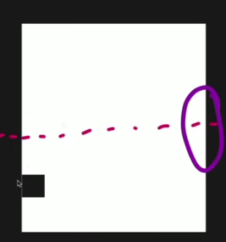
Disadvantages
- This cannot give us edges which are horizontally oriented.
- The result of convolving the filter to find horizontal edge will always result in 0.
- Sobel filter can only detect vertical edges not horizontal but you can detect horizontal also by getting the transpose of sobel filter
- If the whole filter fits in complete black area or complete white area then the computation result will be 0.
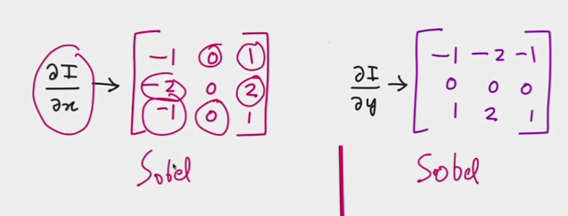
Vertical Horizontal

Prewitt filter: A simplified alternative to sobel
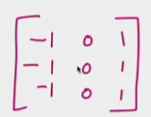 => Same concept as Sobel.
TargetCenter = right - left + (topright - topleft) + (bottomright - bottomleft)
Sobel is preferred compared to Prewitt.

Laplacian Filter: Second derivative.
Sobel and Prewitt -> Finite difference approximation of First derivative of intensity.

Second derivative is a way of enhancing the presence of an edge much better.
Edge = dI/dx => (Initially high) -> (0 if there is an edge) -> high (no edge)
d/dx(dI/dx) = second derivative -> even more variation.
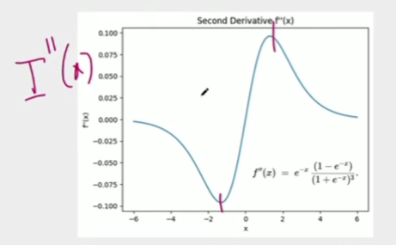

For any filter when we sum everything in the filter the sum = 0. If the sum is non zero then it means that there is an edge

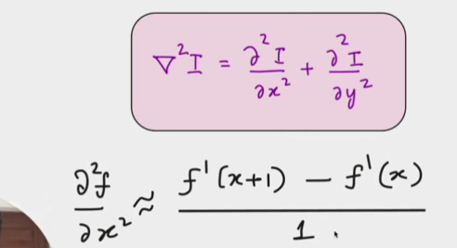
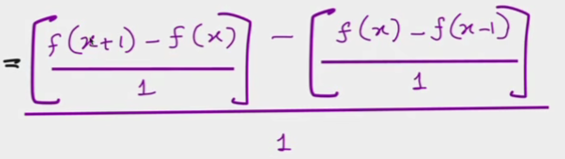

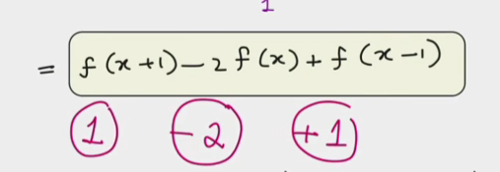

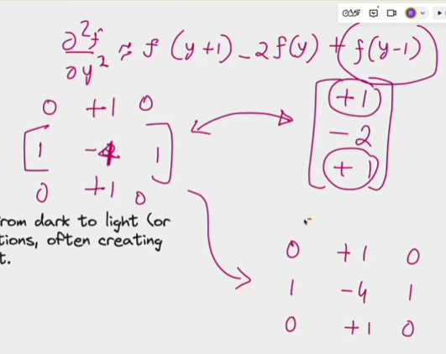 = Laplacian filter

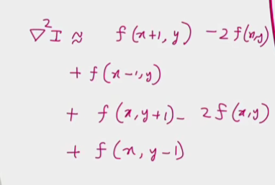

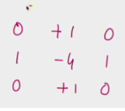 = Laplacian filter

Filters are symmetric -> Sobel and Prewitt filters
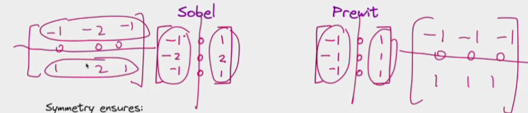

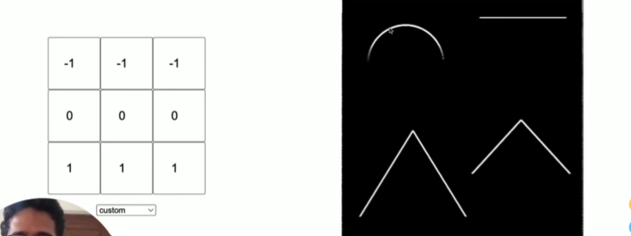 => prewitt filter

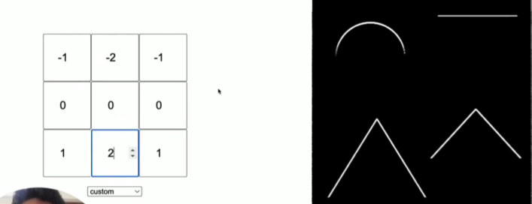 = sober
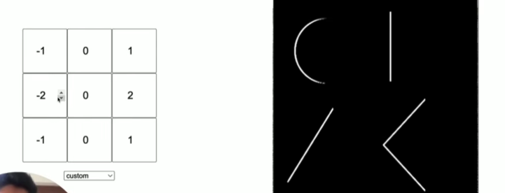

If we want to detect all the edges simultaneously , we use laplacian filter
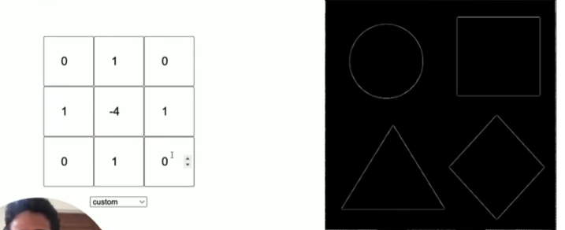

Think of multiple rays of light illumination
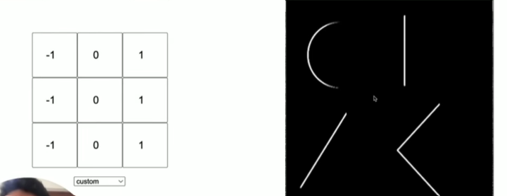
Light rays moving from left to right. Left side gets illuminated

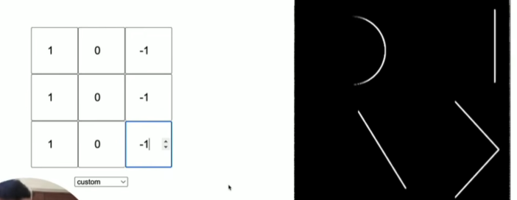
Light rays are moving from right to left. Right gets illuminated

Top illumination
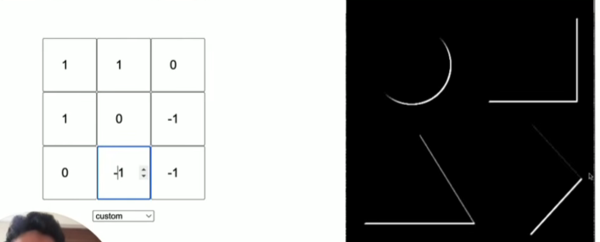
4. Slant

—------------------------------------------------------------------------------------------------

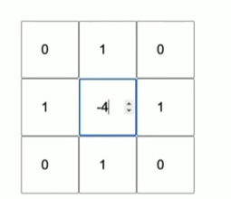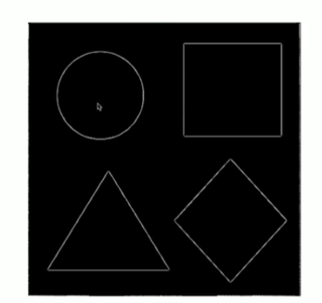
Source of light is inside radiating towards all the directions.

Light is going from negative to positive.

Todo
Blurring,
Denoising

